Student name: Fatima Hussain
Roll Number : 918851
Course : Agentic AI

STEP 1: schedule trigger

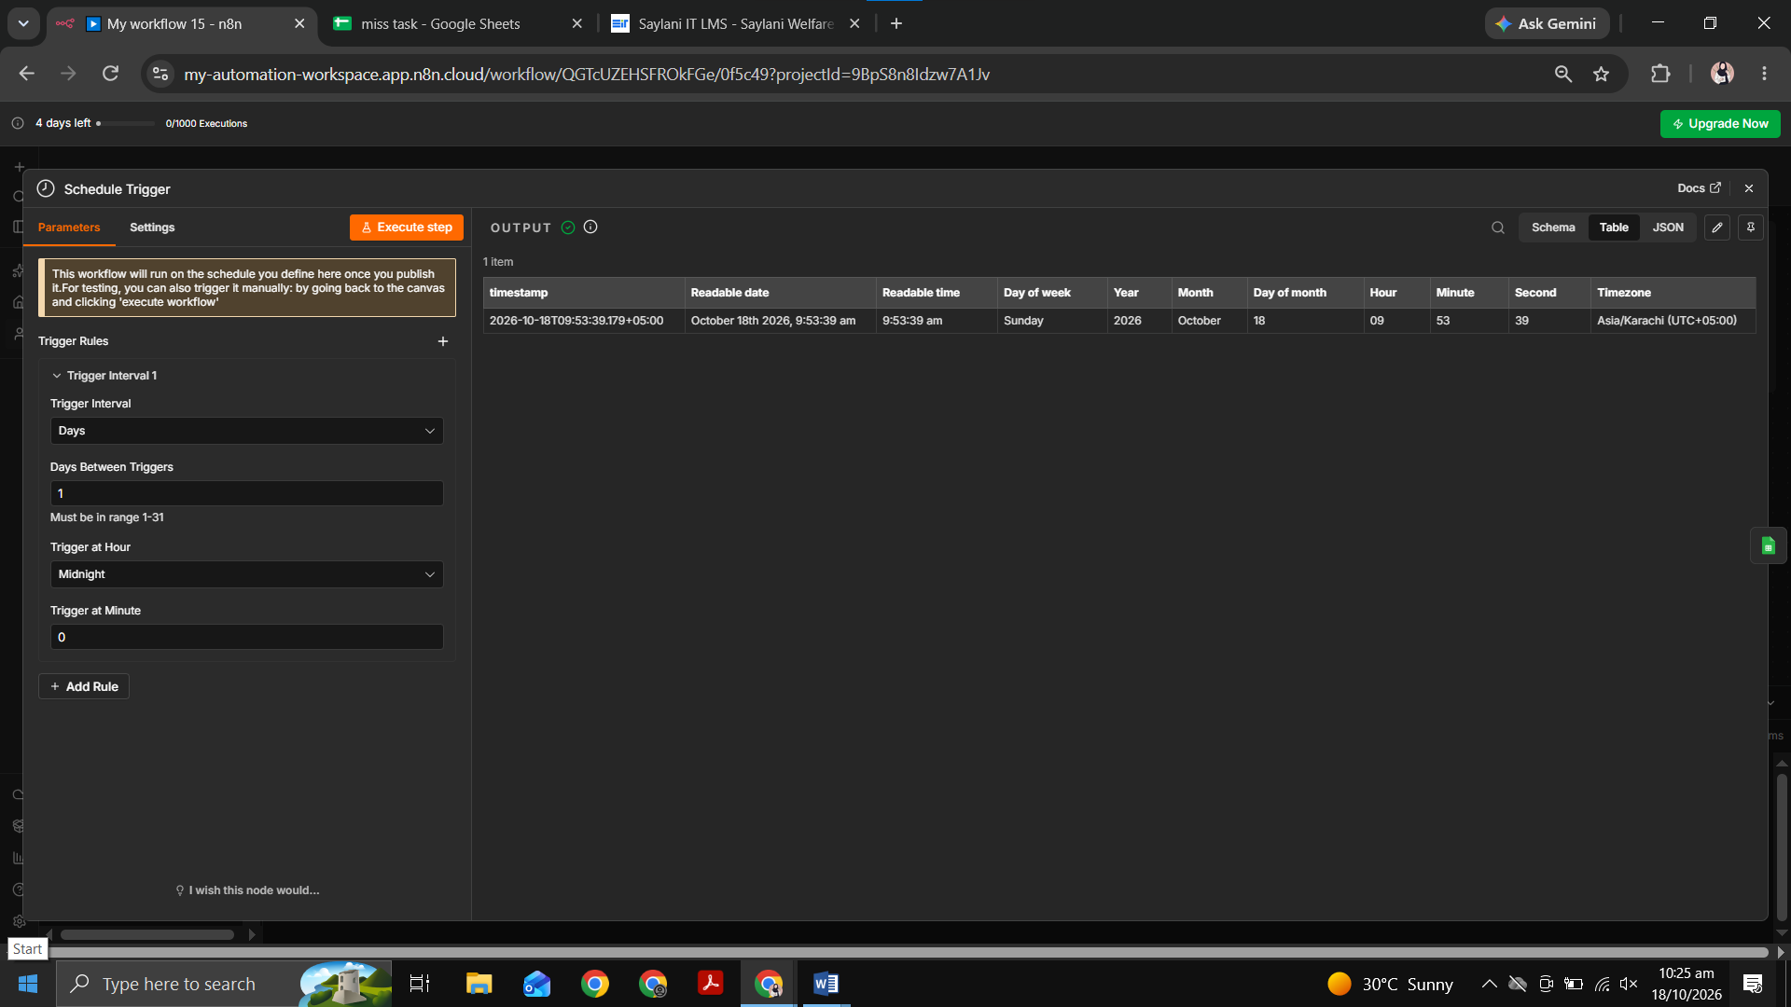

STEP 2: GOOGLE SHEETS (Get row)
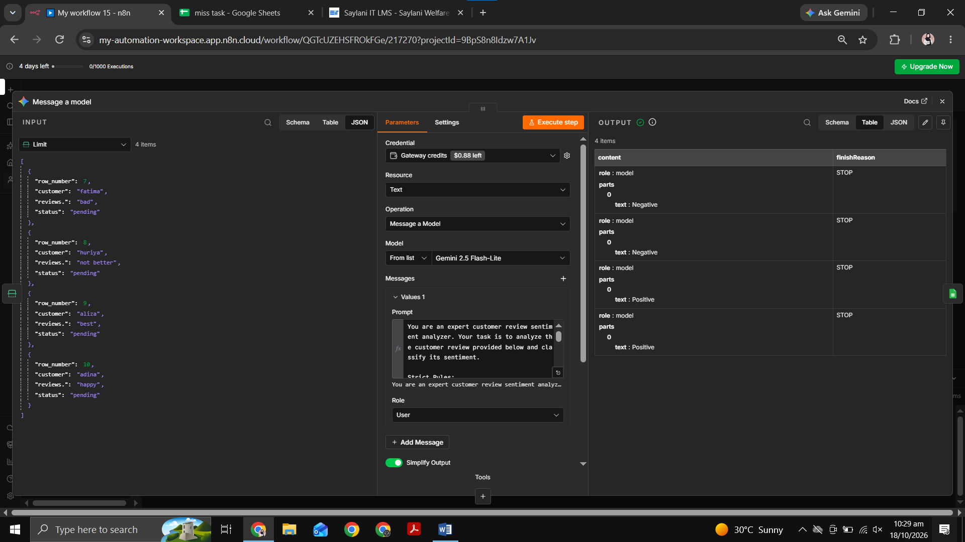
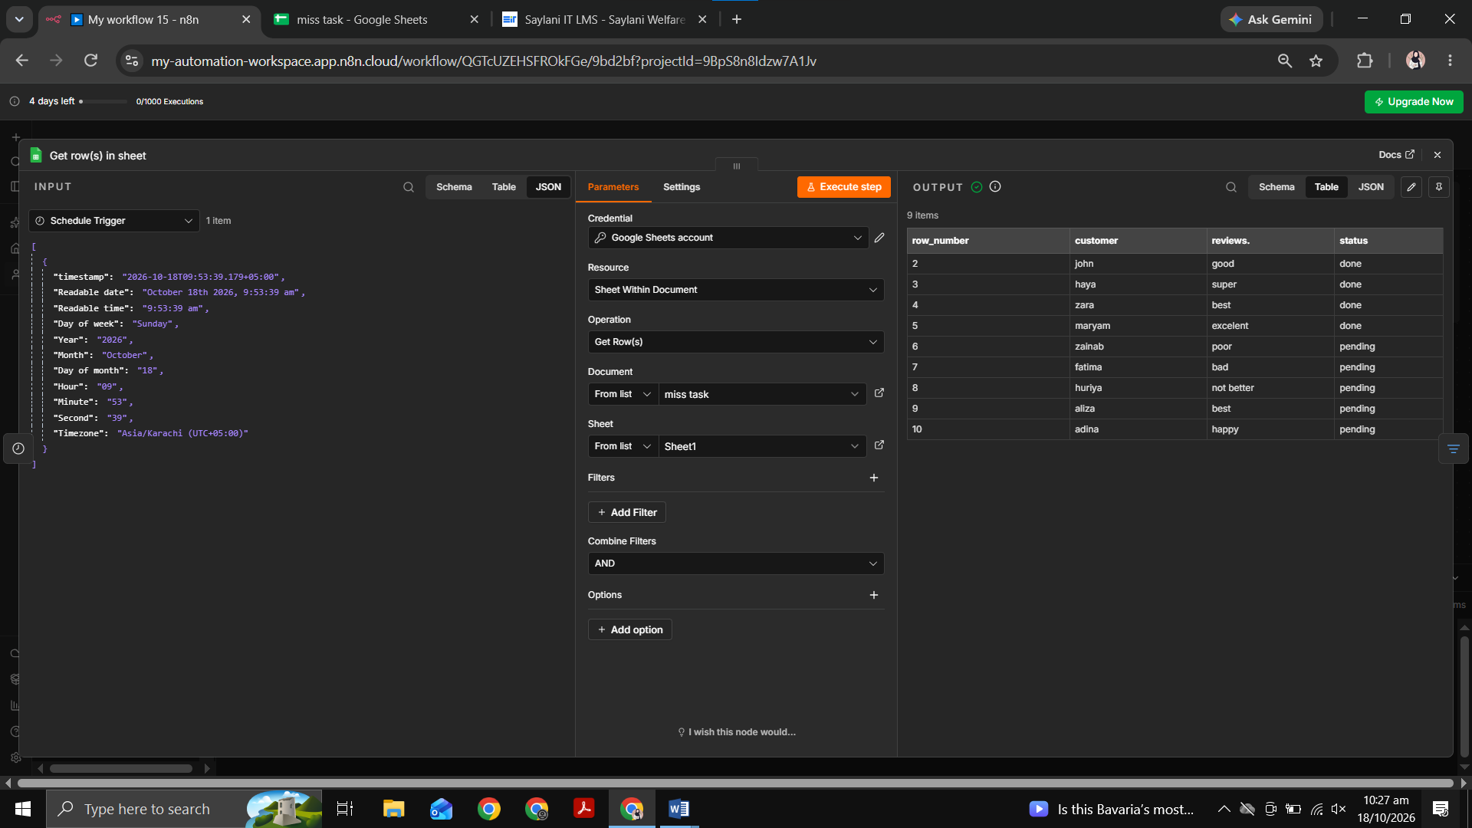

STEP 3: FILTER
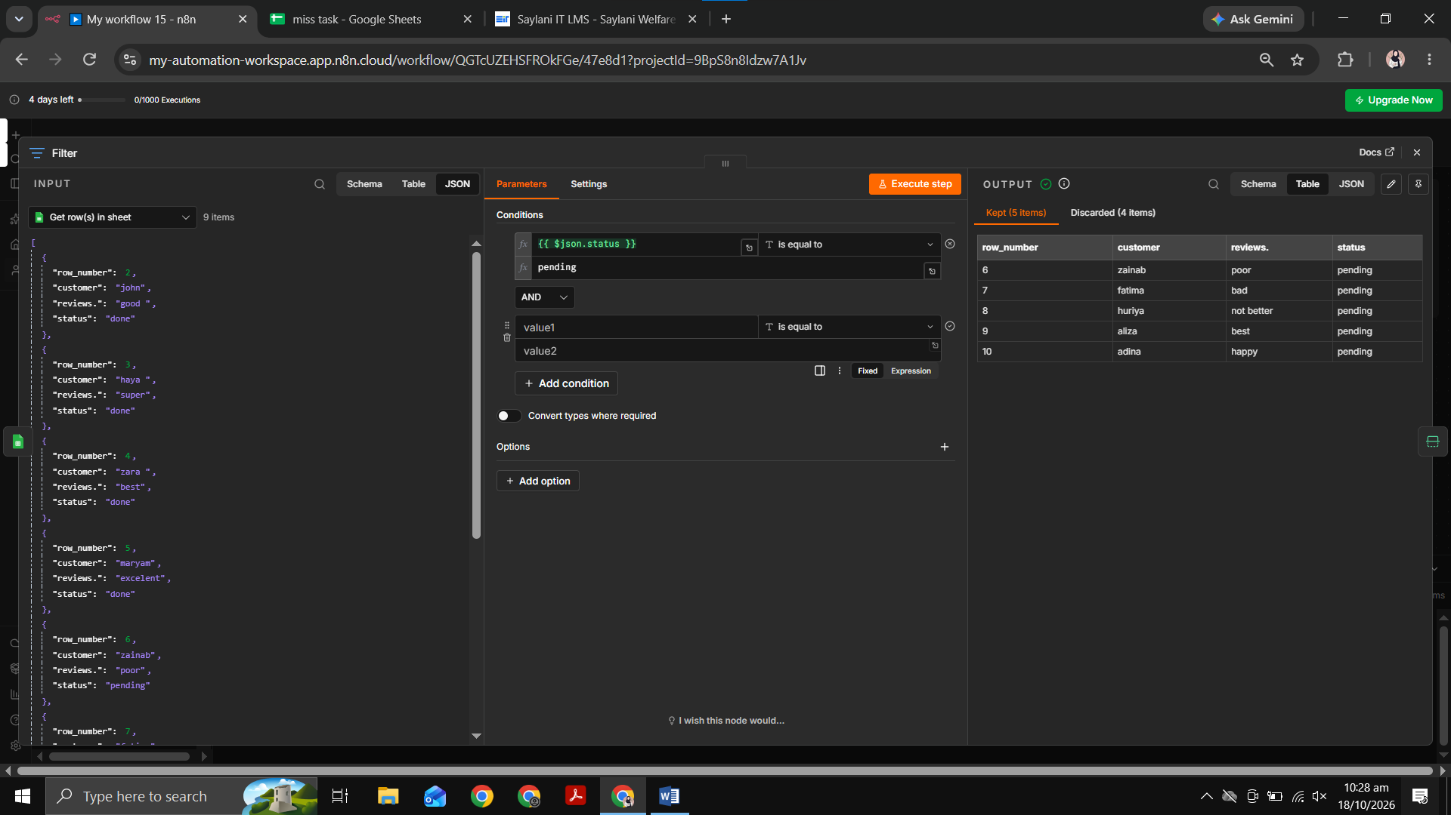

STEP 4: LIMIT

STEP 5: MESSAGE A MODEL

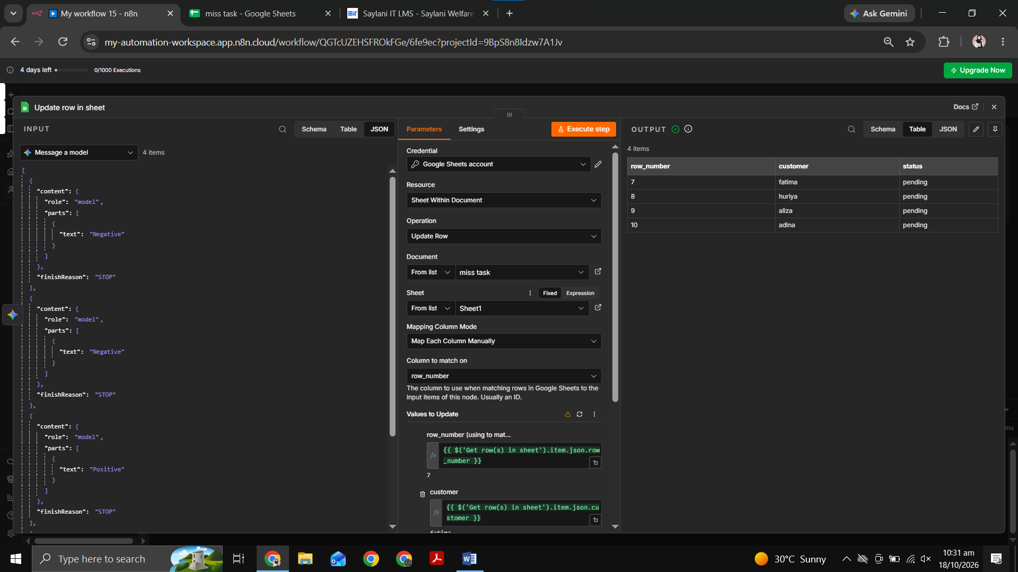

FINAL RESULT:
